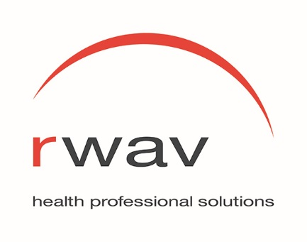

RWAV Board Member Role Description

Position Title: Board Member, Rural Workforce Agency, Victoria (RWAV)

Rural Workforce Agency, Victoria Limited (RWAV) is a not-for-profit company limited by guarantee with a mission to develop and deliver solutions to enhance rural, regional and Aboriginal communities’ access to health workforce.

Function: The Board’s key responsibility is to ensure that RWAV achieves its mission and strategic goals, and in doing so, meets all legal and moral responsibilities and requirements. Directors should endeavour to apply and achieve the highest possible standards of corporate governance. Directors should always act in the best interests of RWAV and in a manner based on transparency, accountability and responsibility.

Qualifications and Skills: Knowledge and skills in areas of Board governance including:

- Legal and financial accountability
- Strategic planning
- Revenue generation
- Advocacy & stakeholder engagement
- Self-evaluation

Requirements:

- Commitment to the objects of RWAV
- Set the strategic direction, priorities and performance criteria
- Agreement to abide by RWAV’s Code of Conduct for Directors and the highest possible standards of governance
- Ensure that RWAV remains in strong financial health
- Identify, categorise and prioritise risks and ensure that strategies to minimise or mitigate risks are in place
- To be informed about and to monitor the industry and environment within which RWAV operates
- Determine the appointment of the Chief Executive Officer and monitor and evaluate the Chief Executive’s performance
- A commitment to continuous quality improvement
- Prepare for and participate in the discussions and deliberations of the Board
- Be informed of RWAV’s services and publicly support them
- Be aware and abstain from any conflict of interest

Major Duties:

- Govern RWAV by the broad policies developed by the Board
- Establish overall long and short-term goals, objectives and priorities in meeting the needs of regional and rural Victorian communities
- Recommend policy to the Board
- Be accountable to funders for services provided and funds expended
- Monitor and evaluate RWAV’s effectiveness through a regular review of programs and services
- Provide constructive criticism, advice and comments
- Approve major actions, such as expenditure, major program and service changes
- Ensure that Board performance is reviewed annually
- Foster a positive working relationship with the Chief Executive Officer
- Be assured that management and Board succession is being properly provided for
- Appoint independent auditors subject to approval by members
- Review and ensure compliance with all relevant legislation affecting RWAV and its operations

